Task #2

Multiple Sequence Alignment (MSA) of Hemoglobin Beta Protein Family
Introduction
Multiple Sequence Alignment (MSA) is a bioinformatics method used to align multiple DNA, RNA, or protein sequences to identify conserved regions, functional motifs, and evolutionary relationships. It is commonly applied in phylogenetic studies, protein structure prediction, and gene/protein annotation. In this study, five Hemoglobin Beta (HBB) protein sequences were aligned using the Clustal Omega tool. HBB is a highly conserved oxygen-transport protein in vertebrates, reflecting its critical role in oxygen delivery.
Objective
- To select at least five protein sequences from the same protein family.
- To perform Multiple Sequence Alignment using Clustal Omega.
- To identify conserved regions and functional motifs.
- To interpret the biological significance of the alignment results.
Protein Sequences Selected
The selected protein family is Hemoglobin Beta (HBB) protein.
The five protein sequences used for Multiple Sequence Alignment (MSA) are:
- Hemoglobin Beta (HBB) Human (Homo sapiens)
- Hemoglobin Beta (HBB) Chimpanzee (Pan troglodytes)
- Hemoglobin Beta (HBB) Mouse (Mus musculus)
- Hemoglobin Beta (HBB) Rat (Rattus norvegicus)
- Hemoglobin Beta (HBB) Cow (Bos taurus)

FASTA Sequences Used
Human_HBB
MVHLTPEEKSAVTALWGKVNVDEVGGEALGRLLVVYPWTQRFFESFGDLSTPDAVMGNPKVKAHGKKVLGAFSDGLAHLDNLKGTFATLSELHCDKLHVDPENFRLLGNVLVCVLAHHFGKEFTPPVQAAYQKVVAGVANALAHKYH
Chimp_HBB
MVHLTPEEKSAVTALWGKVNVDEVGGEALGRLLVVYPWTQRFFESFGDLSTPDAVMGNPKVKAHGKKVLGAFSDGLAHLDNLKGTFATLSELHCDKLHVDPENFRLLGNVLVCVLAHHFGKEFTPPVQAAYQKVVAGVANALAHKYH
>Mouse_HBB
MVHLTDAEKAAVNGLWGKVNPDDVGGEALGRLLVVYPWTQRFFDSFGDLSNPGAVMGNPKVKAHGKKVLAAFSEGLSHLDNLKGTFAALSELHCDKLHVDPENFRLLGNVLVVVLARHFGKEFTPQVQAAYQKVVAGVANALAHKYH

>Rat_HBB
MVHLTDAEKAAVNGLWGKVNPDDVGGEALGRLLVVYPWTQRFFDSFGDLSNPGAVMGNPKVKAHGKKVLAAFSEGLSHLDNLKGTFAALSELHCDKLHVDPENFRLLGNVLVVVLARHFGKEFTPQVQAAYQKVVAGVANALAHKYH

>Cow_HBB
MVHLTPEEKSAVTALWGKVNVDEVGGEALGRLLVVYPWTQRFFDSFGDLSNPGAVMGNPKVKAHGKKVLHSFGEGVHHLDNLKGTFATLSELHCDKLHVDPENFRLLGNVLVCVLAHHFGKEFTPPVQAAYQKVVAGVANALAHKYH

Alignment Results
The Multiple Sequence Alignment generated by Clustal Omega showed a high degree of sequence similarity among all five hemoglobin beta proteins.
Human MVHLTPEEKSAVTALWGKVNVDEVGGEALGRLLVVYPWTQRFFESFGDLSTPDAVMGNP
Chimp MVHLTPEEKSAVTALWGKVNVDEVGGEALGRLLVVYPWTQRFFESFGDLSTPDAVMGNP
Mouse MVHLTDAEKAAVNGLWGKVNPDDVGGEALGRLLVVYPWTQRFFDSFGDLSNPGAVMGNP
Rat MVHLTDAEKAAVNGLWGKVNPDDVGGEALGRLLVVYPWTQRFFDSFGDLSNPGAVMGNP
Cow MVHLTPEEKSAVTALWGKVNVDEVGGEALGRLLVVYPWTQRFFDSFGDLSNPGAVMGNP
******:*:*::* ******:*************************.****::*:***
In the Clustal Omega alignment:
- * indicates fully conserved amino acids.
- : indicates strongly similar amino acids.
- . indicates weakly similar amino acids.
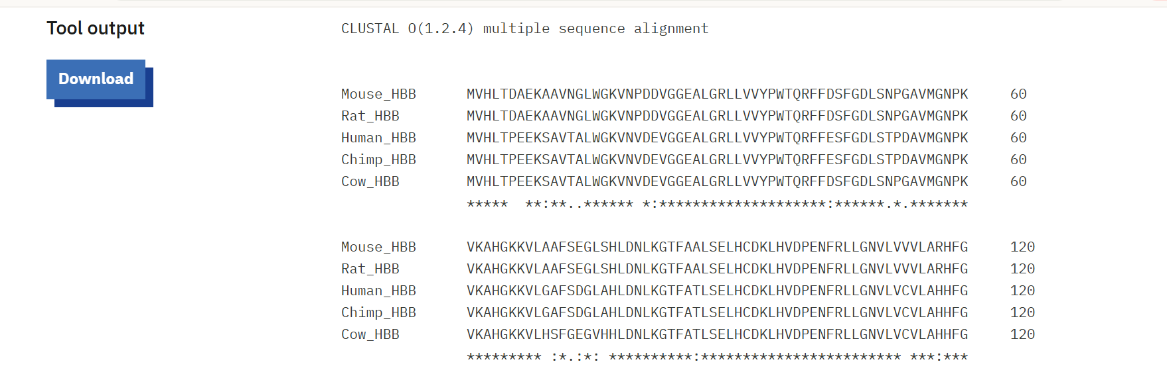

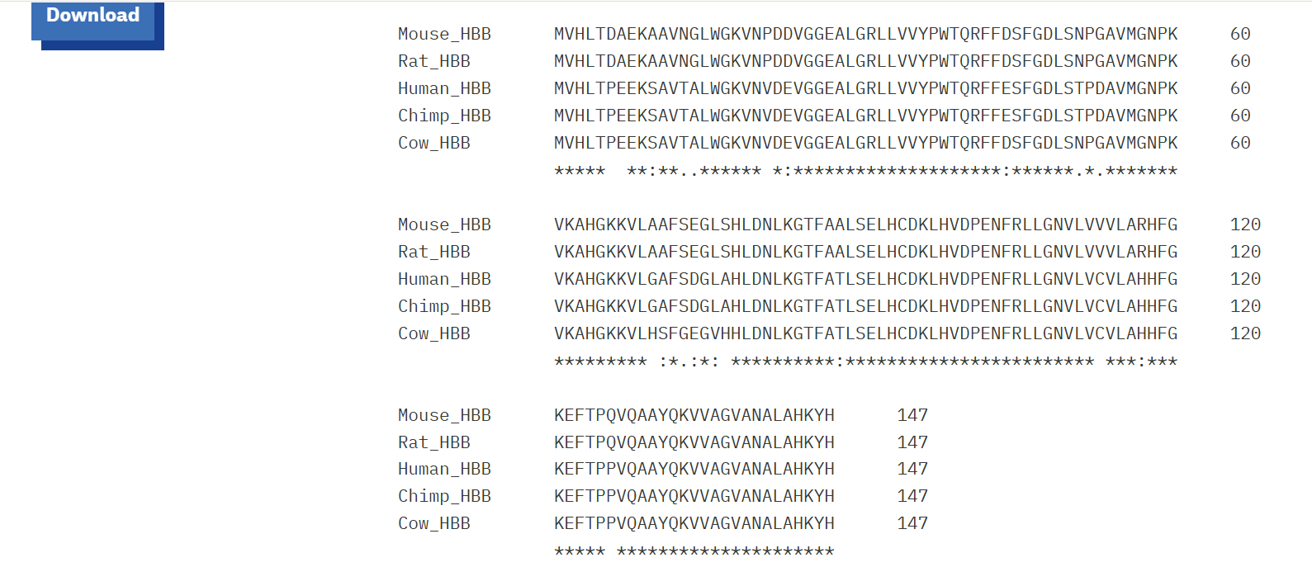

Conserved Regions and Motifs
Several highly conserved regions were observed across all species:
GRLLVVYPWTQRFF
KVKAHGKKV
QKVVAGVANALAHKYH
These conserved regions are functionally important because they contribute to:
- Oxygen binding
- Heme interaction
- Structural stability of hemoglobin
One important conserved motif identified was:
VVYPWTQRFF
Interpretation and Discussion
The alignment showed that hemoglobin beta proteins are highly conserved among vertebrates. Human and chimpanzee sequences were identical, indicating a close evolutionary relationship, while mouse and rat sequences were also highly similar. The cow sequence showed only minor amino acid differences.
The conserved residues are important for hemoglobin function, especially oxygen transport and heme binding. Small sequence variations likely reflect evolutionary adaptations while preserving the protein’s primary role. Overall, the analysis highlights the evolutionary relationship and functional importance of conserved protein regions.

Conclusion
Multiple Sequence Alignment of five hemoglobin beta protein sequences was successfully performed using Clustal Omega. The analysis revealed extensive conservation among vertebrate hemoglobin proteins and identified important conserved motifs involved in oxygen transport and structural stability. The results demonstrate the evolutionary conservation of functionally important protein regions and highlight the usefulness of MSA in comparative bioinformatics studies.

